use pubs

-- 1) Select all the author's details

SELECT * FROM authors

-- 2) Print all the author's full name

SELECT CONCAT(au_fname,' ', au_lname) 'Author Full Name' FROM authors

ORDER BY 1

-- 3) Print the average price , total price of all the titles

SELECT AVG(price) 'Average Price', SUM(price) 'Total Price' FROM titles

-- 4) Print the average price of a titles published by '0736'

SELECT pub_id 'Publisher ID', AVG(price) 'Average Price' FROM titles

WHERE pub_id = '0736'

GROUP BY pub_id

-- 5) Print the titles which have advance min of 3200 and maximum of 5000

SELECT title 'Title', advance 'Advance'FROM titles

WHERE advance > 3200 AND advance < 5000

-- 6) Print the titles which are of type 'psychology' or 'mod_cook'

SELECT title 'Title', type 'Type' FROM titles

WHERE type = 'psychology' OR type = 'mod_cook'

-- 7) Print all titles published before '1991-06-09 00:00:00.000'

SELECT title 'Title', pubdate 'Publish Date' FROM titles

WHERE pubdate < '1991-06-09 00:00:00.000'

-- 8) Select all the authors from 'CA'

SELECT * FROM authors

WHERE state = 'CA'

-- 9) Print the average price of titles in every type

SELECT type 'Type', AVG(price) 'Average Price' FROM titles

GROUP BY type

-- 10) Print the sum of price of all the books pulished by every publisher

SELECT pub_id 'Publisher ID', SUM(price) 'Total Price' FROM titles

GROUP BY pub_id

-- 11) Print the first published title in every type --edit just the type and first pub date

SELECT type 'Type', MIN(pubdate) 'Published Date' FROM titles

GROUP BY type

-- 12) Calculate the total royalty for every publisher

SELECT P.pub_id 'Publisher ID', SUM(royalty) 'Total Royalty'

FROM titles T RIGHT OUTER JOIN publishers P

ON T.pub_id = P.pub_id

GROUP BY P.pub_id

-- 13) Print the titles sorted by published date

SELECT title 'Title', pubdate 'Publised Date' FROM titles

ORDER BY pubdate

-- 14) Print the titles sorted by publisher then by price

SELECT title 'Title', pub_id 'Publisher ID', price 'Price' FROM titles

ORDER BY pub_id, price

-- 15) Print the books published by authors from 'CA'

SELECT DISTINCT T.title 'Title'

FROM titles T JOIN titleauthor TA

ON T.title_id = TA.title_id

JOIN authors A ON A.au_id = TA.au_id

WHERE state = 'CA'

ORDER BY 1

-- 16) Print the author name of books which have royalty more than the average royalty of all the titles

SELECT CONCAT(A.au_fname, ' ', A.au_lname) 'Author Full Name'

FROM titles T JOIN titleauthor TA

ON T.title_id = TA.title_id

JOIN authors A ON A.au_id = TA.au_id

WHERE royalty > (SELECT AVG(royalty) FROM titles)

ORDER BY 1

-- 17) Print all the city and the number of pulishers in it, only if the city has more than one publisher

SELECT city 'City', COUNT(DISTINCT pub_id) 'No. of Publisher' FROM publishers

GROUP BY city

HAVING COUNT(DISTINCT pub_id) > 1

--no result

-- 18) Print the total number of orders for every title

SELECT title_id 'Title ID', COUNT(title_id) 'Total number of orders' FROM sales

GROUP BY title_id

-- 19) Print the total number of titles in every order

SELECT ord_num 'Order No.', COUNT(title_id) 'Total Titles' FROM sales

GROUP BY ord_num

-- 20) Print the order date and the title name

SELECT T.title 'Title Name', S.ord_date 'Order Date'

FROM sales S JOIN titles T

ON S.title_id = T.title_id

ORDER BY 2

-- 21) Print all the title names and publisher names

SELECT T.title 'Title Name', P.pub_name 'Publisher Name'

FROM titles T JOIN publishers P

ON T.pub_id = P.pub_id

-- 22) print all the publisher names(even if they have not published) and the title names that they have published

SELECT P.pub_name 'Publisher Name', T.title 'Title Name'

FROM titles T RIGHT OUTER JOIN publishers P

ON T.pub_id = P.pub_id

-- 23) print the title id and the numebr of authors contributing to it

SELECT title_id 'Title ID', COUNT(DISTINCT au_id) 'No. of Author' FROM titleauthor

GROUP BY title_id

ORDER BY 1

-- 24) Print the title name and the author name

SELECT T.title 'Title Name', CONCAT(A.au_fname, ' ', A.au_lname) 'Author Name'

FROM titles T JOIN titleauthor TA

ON T.title_id = TA.title_id

JOIN authors A ON A.au_id = TA.au_id

ORDER BY T.title

-- 25) print the title name, author name and the publisher name

SELECT T.title 'Title Name', CONCAT(A.au_fname, ' ', A.au_lname) 'Author Name', P.pub_name 'Publisher Name'

FROM authors A JOIN titleauthor TA

ON A.au_id = TA.au_id

JOIN titles T ON T.title_id = TA.title_id

JOIN publishers P ON P.pub_id = T.pub_id

ORDER BY 1

-- 26) print the title name, author name, publisher name, orderid, order date, quantity ordered and the total price

SELECT T.title 'Title Name', CONCAT(A.au_fname, ' ', A.au_lname) 'Author Name', P.pub_name 'Publisher Name',

S.ord_num 'Order ID', S.ord_date 'Order Date', S.qty 'Quanitity Ordered', S.qty*T.price 'Total Price'

FROM authors A JOIN titleauthor TA

ON A.au_id = TA.au_id

JOIN titles T ON T.title_id = TA.title_id

JOIN publishers P ON P.pub_id = T.pub_id

JOIN sales S ON S.title_id = T.title_id

ORDER BY 1

-- 27) given a title name print the stores in which it was sold

SELECT T.title 'Title Name', SR.stor_name 'Store Name'

FROM titles T JOIN sales SS

ON T.title_id = SS.title_id

JOIN stores SR ON SR.stor_id = SS.stor_id

WHERE title = 'But Is It User Friendly?'

-- 28) Select the stores who have taken more than 2 orders

SELECT stor_id 'Store ID', COUNT(stor_id) 'Total Order'

FROM sales

GROUP BY stor_id

HAVING COUNT(stor_id) > 2

-- 29) Select all the titles and print the first order date (titles that have not be ordered should also be present)

SELECT T.title_id 'Title ID', MIN(S.ord_date)

FROM titles T LEFT OUTER JOIN sales S

ON T.title_id = S.title_id

GROUP BY T.title_id

-- 30) select all the data from the orders and the authors table

SELECT * FROM sales, authors

**Output:**

Question 1:

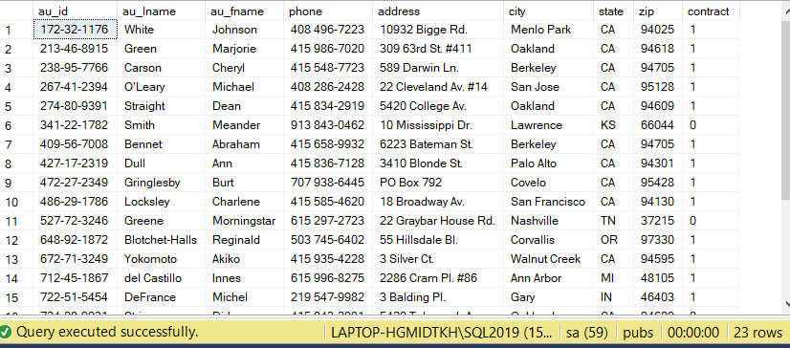

Question 2:

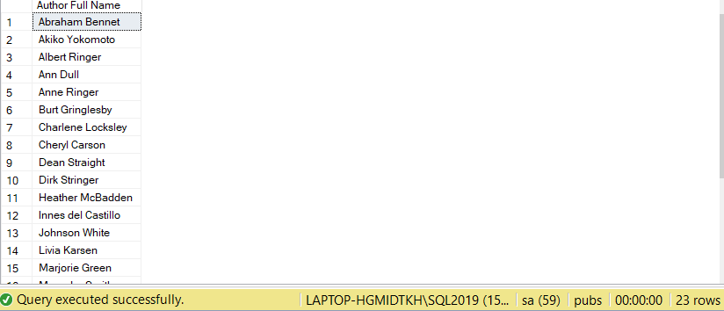

Question 3:



Question 4:



Question 5:



Question 6:

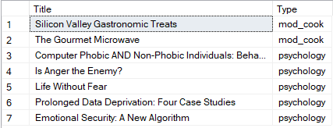

Question 7:



Question 8:

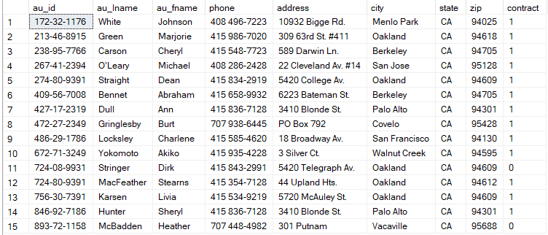

Question 9:

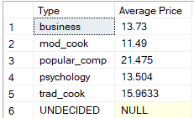

Question 10:

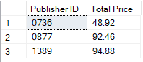

Question 11:

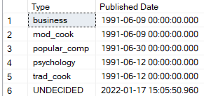

Question 12:

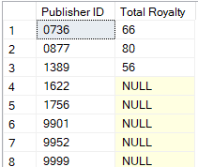

Question 13:

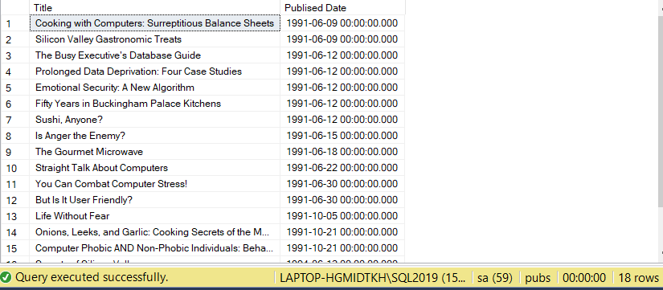

Question 14:

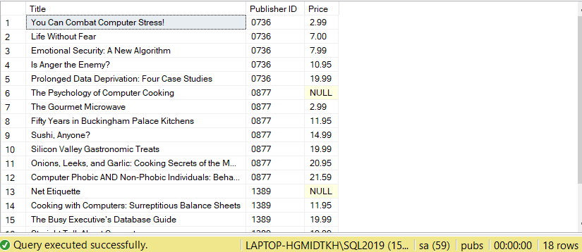

Question 15:

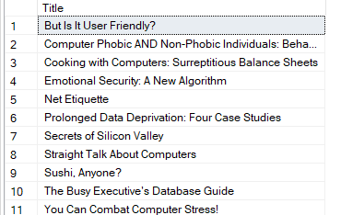

Question 16:

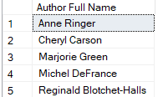

Question 17:



Question 18:

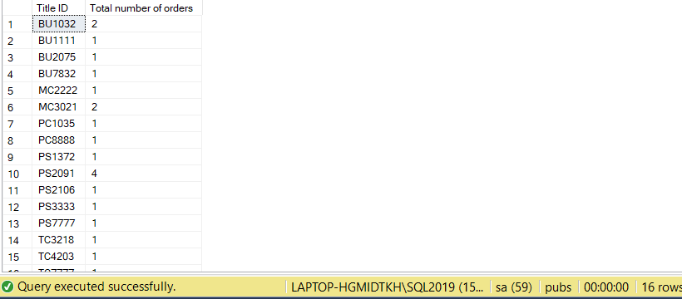

Question 19:

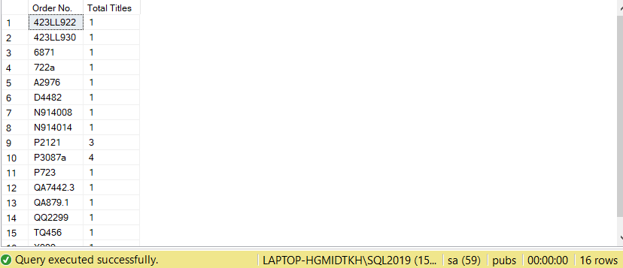

Question 20:

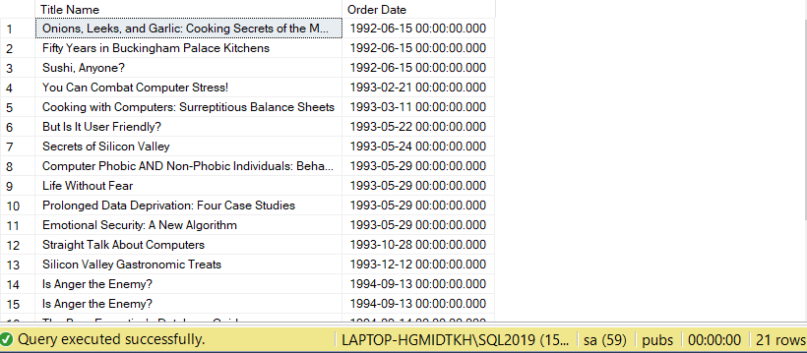

Question 21:

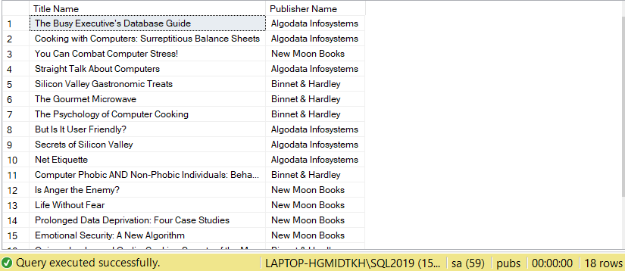

Question 22:

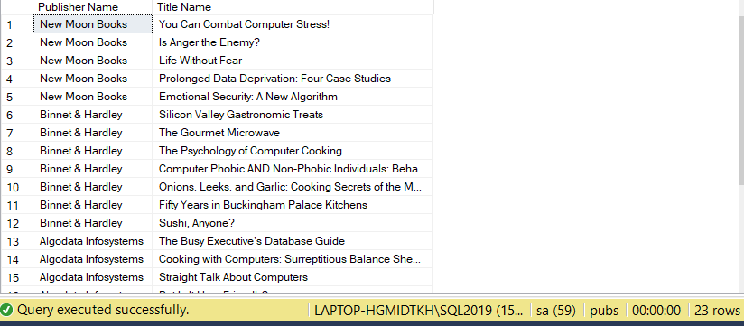

Question 23:

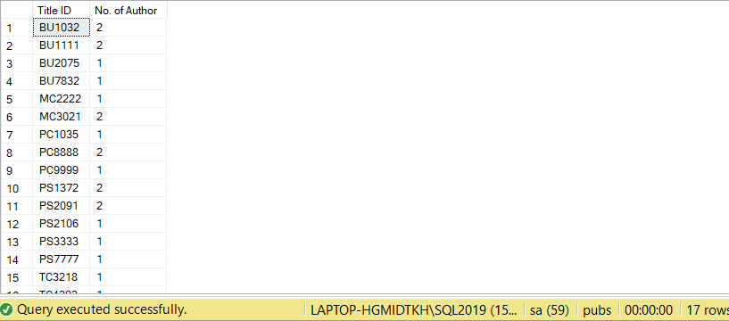

Question 24:

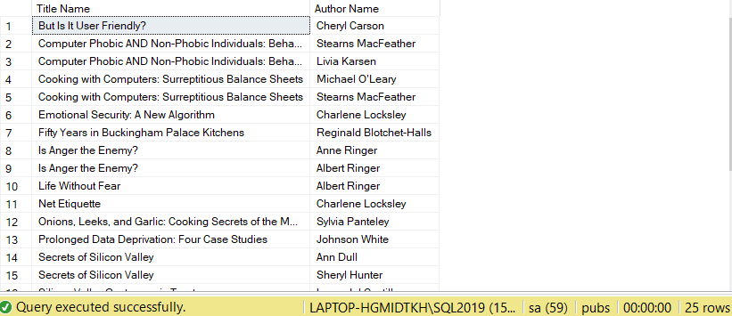

Question 25:

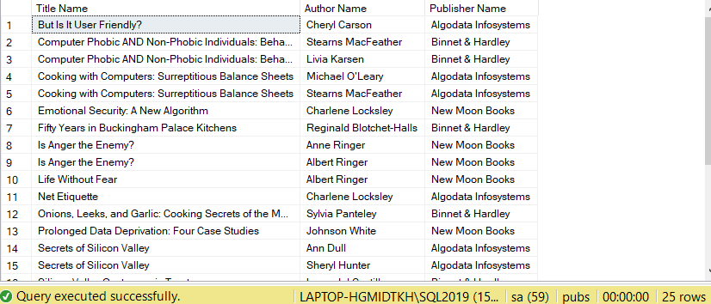

Question 26:

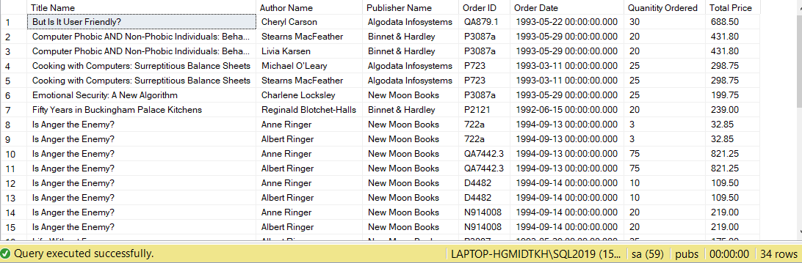

Question 27:



Question 28:

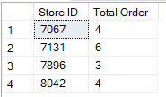

Question 29:

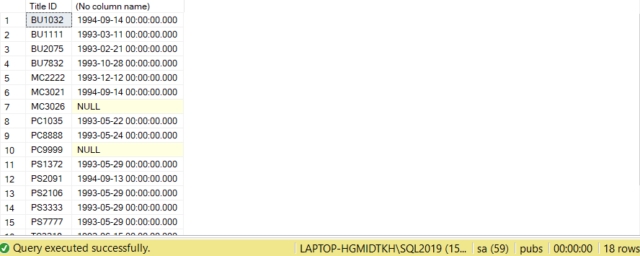

Question 30:

